Advance Excel Assignment 3

1. How and when to use the AutoSum command in excel?

2. What is the shortcut key to perform AutoSum?

3. How do you get rid of Formula that omits adjacent cells?

4. How do you select non-adjacent cells in Excel 2016?

5. What happens if you choose a column, hold down the Alt key and press the letters

ocw in quick succession?

6. If you right-click on a row reference number and click on Insert, where will the row

be added?

**1. How and when to use the AutoSum command in excel?**

Ans. AutoSum is a command in Excel that is found in the Home Tab section. When you need to add a range of numbers present in the cells whether in a column format or row format, you can use AutoSum to automatically make an appropriate SUM formula for you.

The Autosum Excel function can also be accessed by typing ALT + the = sign in a spreadsheet, and it will automatically create a formula to sum all the numbers in a continuous range

How does Autosum Excel work?

The Autosum Excel shortcut is method is **ALT =**

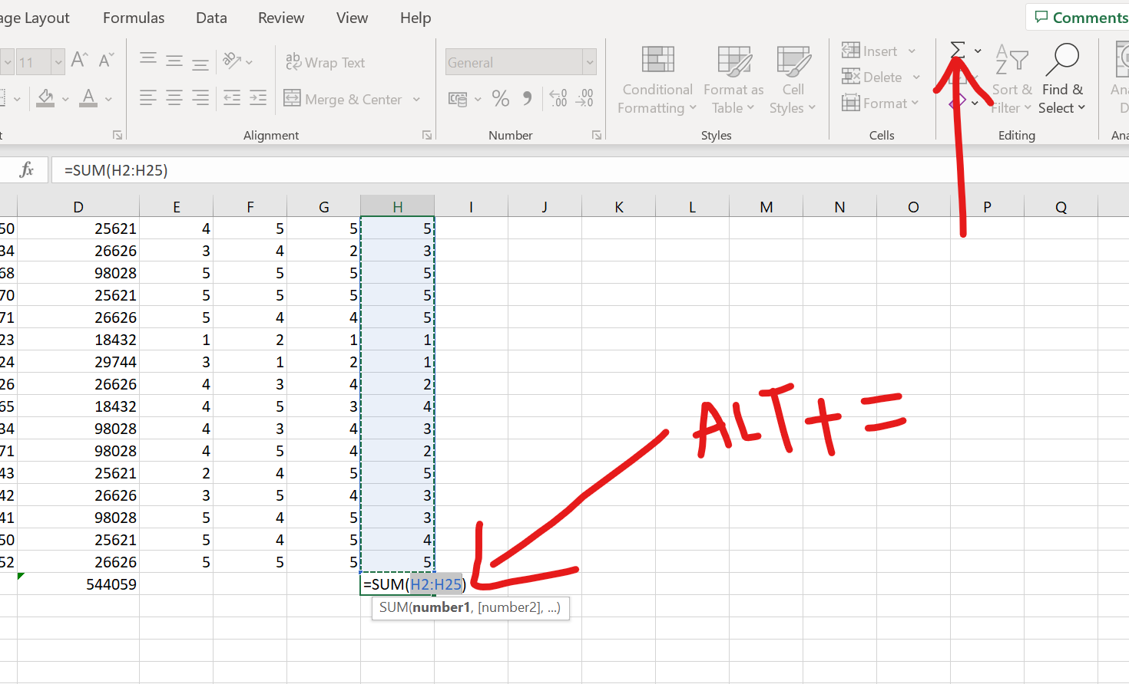

Step 1: Place the cursor below the column of numbers you want to sum (or to the left of the row of numbers you want to sum).

Step 2:Now hold down the Alt key and then press the equals = sign while still holding Alt.

Step 3:Finally, press Enter.

**2. What is the shortcut key to perform AutoSum?**

Shortcut used to perform AutoSum is **ALT + =**

After selecting a column or a row end where you want the values to be displayed press ALT and =, the results will be displayed at the selected cell .

**3. How do you get rid of Formula that omits adjacent cells?**

This error usually happens when we are trying to add cells in a column and suppose if the top header contains a numerical value or date value in mm-yyyy format, excel might consider it as a numerical value and a triangle icon will be visible on the top left corner of the cell.

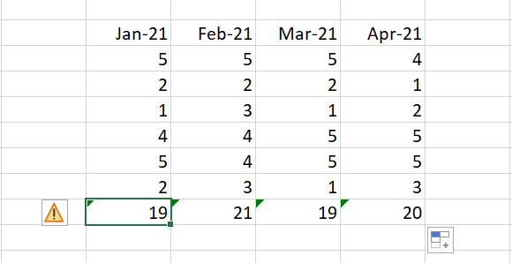

When you get this error, click on the yellow button and click on ignore error , you select the cells that are wrongly throwing error and click on this option, The issue will be automatically fixed. If the issue is genuine then click on update formula and it will update the right value.

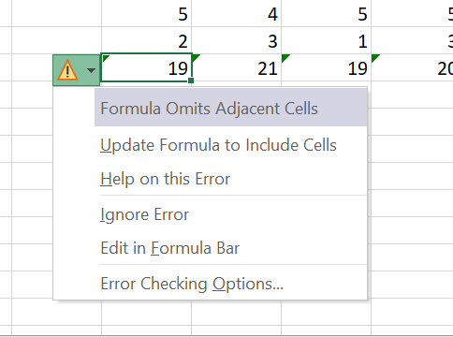

**4. How do you select non-adjacent cells in Excel 2016?**

To select non adjacent cells in excel 2016:

1.Firstly, click on the first cell that you want to select. After selection,simultaneously hold the Contro(CTRL)l key on your keyboard

Left-click on the mouse and drag to make the selection

Stop clicking the mouse button.Now, you will have a range of selection. Keep holding the Control key.

Now Place the cursor on the second cell or range that you want to select

Left-click on the mouse and drag to make the selection

Leave the mouse click. This would select two non-contiguous ranges of cells.

Release the Control key

**5.What happens if you choose a column, hold down the Alt key and press the letters**

**ocw in quick succession?**

So when we choose a column randomly, hold down ALT key and type ocw quickly the column width window will open up and we can customize the width of the selected cells accordingly.

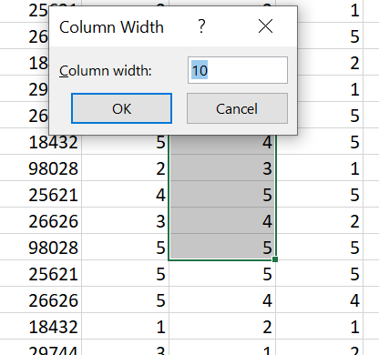

**6. If you right-click on a row reference number and click on Insert, where will the row**

**be added?**

If you right-click on the row reference number and click on Insert the row will be added above the row reference number that you had right clicked on.

If you ctrl and select two or more non adjacent rows then the rows will be inserted above every selected row, when you click on INSERT